

A Project Report on

WELLNESS METRICS UNVEILED:POWERING HEALTHCARE WITH SMART INSIGHTS!

Submitted in partial fulfillment of requirements for the award of the course

of

ADI1211 – BUSINESS INTELLIGENCE
Under the guidance of

Ms. S .SUBHA SRI M.E.,

IBM Software Technical Trainer/AI&DS

Submitted By

DHIVAKAR S (927623BAD027)

DEPARTMENT OF ARTIFICIAL INTELLIGENCE

M.KUMARASAMY COLLEGE OF ENGINEERING
(Autonomous)

KARUR – 639 113

May 2025

i

M. KUMARASAMY COLLEGE OF ENGINEERING (Autonomous Institution affiliated to Anna University, Chennai)

KARUR – 639 113

BONAFIDE CERTIFICATE

Certified that this project report on “Wellness Metrics Unveiled: Powering Healthcare with Smart Insights!” is bonafide work of DHIVAKAR S (927623BAD027) who carried out the project work during the academic year 2024 - 2025 under my supervision.

Signature Signature

Ms. S. SUBHA SRI ,M.E., Dr. A.SELVI (Ph.D.,)

IBM Software Technical Trainer, HEAD OF THE DEPARTMENT,

Department of Artificial Intelligence, Department of Artificial Intelligence,

M.Kumarasamy College of Engineering,
M.Kumarasamy College of Engineering,

Thalavapalayam, Karur -639 113. Thalavapalayam, Karur -639 113.

DEPARTMENT OF ARTIFICIAL INTELLIGENCE

VISION OF THE INSTITUTION

To emerge as a leader among the top institutions in the field of technical education

MISSION OF THE INSTITUTION

- Produce smart technocrats with empirical knowledge who can surmount the global challenges
- Create a diverse, fully-engaged, learner-centric campus environment to provide quality education to the students
- Maintain mutually beneficial partnerships with our alumni, industry, and Professional associations

VISION OF THE DEPARTMENT

To create highly qualified competitive professionals in Artificial Intelligence and Machine Learningby designing intelligent solutions to solve problems in variety of business domains, applications such as natural language processing, text mining, robotics, reasoning and problem
-solving that serves society with greater cause.

MISSION OF THE DEPARTMENT

M1: Impart practical and technical knowledge along with applications of various integrated technologies.
M2: Design and develop various intelligent engineering projects to solve societal issues.

M3: Use of advanced engineering tools and equipment to enable research based learning to promote ethical values, lifelong learning and entrepreneurial skills.

PROGRAM EDUCATIONAL OBJECTIVES (PEOS)

PEO1: Develop intelligent software solutions demonstrating reasoning, learning and decision support while handling uncertainty using domain knowledge.
PEO2: Create significant research towards social benefits and engineering improvement witha wide breadth knowledge of AI & ML technologies and their applications.
PEO3: Participate in life-long learning for effective professional growth and demonstrate leadership qualities in disruptive technologies along with a capacity to critically analyse and evaluate design proposals.

PROGRAM OUTCOMES

Engineering students will be able to:
PO1: Engineering knowledge: Apply the knowledge of mathematics, science, engineering fundamentals, and an engineering specialization to the solution of complex engineering problems.

PO2: Problem analysis: Identify, formulate, review research literature, and analyze complex engineering problems reaching substantiated conclusions using first principles of mathematics, natural sciences, and engineering sciences.

PO3: Design/development of solutions: Design solutions for complex engineering problems and design system components or processes that meet the specified needs with appropriate consideration for the public health and safety, and the cultural, societal, and environmental considerations.

PO4: Conduct investigations of complex problems: Use research-based knowledge and research methods including design of experiments, analysis and interpretation of data, and synthesis of the information to provide valid conclusions.

PO5: Modern tool usage: Create, select, and apply appropriate techniques, resources, and modern engineering and IT tools including prediction and modeling to complex engineering activities with an understanding of the limitations.

PO6: The engineer and society: Apply reasoning informed by the contextual knowledge to assess societal, health, safety, legal and cultural issues and the consequent responsibilities relevant to the professional engineering practice.

PO7: Environment and sustainability: Understand the impact of the professional engineering solutions in societal and environmental contexts, and demonstrate the knowledge of, and need for sustainable development.

PO8: Ethics: Apply ethical principles and commit to professional ethics and responsibilities and norms of the engineering practice.

PO 9: Individual and team work: Function effectively as an individual, and as a member or leader in diverse teams, and in multidisciplinary settings.

PO10: Communication: Communicate effectively on complex engineering activities with the engineering community and with society at large..

PO11: Project management and finance: Demonstrate knowledge and understanding of the engineering and management principles and apply these to one’s own work, as a member and leader in a team, to manage .

PO12: Life-long learning: Recognize the need for, and have the preparation and ability to engage in independent and life-long learning in the broadest context of technological change.

PROGRAM SPECIFIC OUTCOMES (PSOs)

PSO1: Expertise in tailoring ML algorithms and models to excel in designated applications and fields.

PSO2: Ability to conduct research, contributing to machine learning advancements and innovations that tackle emerging societal challenges.

ABSTRACT

“Wellness Metrics Unveiled” is a dashboard that leverages IBM Cognos Analytics to visualize hospital throughput, patient recovery rates, and critical care efficiency. By analyzing key metrics like bed occupancy, ER wait times, and ICU utilization, it provides real-time insights to optimize hospital operations. This project enables data-driven decision-making, improving resource allocation, patient care, and overall efficiency in healthcare.

ABSTRACT WITH POs AND PSOs MAPPING

ABSTRACT | POs  MAPPED | PSOs  MAPPED
“Wellness Metrics Unveiled” is a healthcare dashboard powered by IBM Cognos Analytics that visualizes key hospital performance indicators such as bed occupancy, ER wait times, patient recovery rates, and ICU utilization. It delivers real-time insights to enhance decision-making, optimize resource allocation, and improve the quality and efficiency of patient care. | PO1(3)  PO2(3)  PO3(3)  PO4(2)  PO5(3)  PO6(2)  PO7(2)  PO8(1)  PO10(2)  PO11(2)  PO12(2) | PSO1(1)  PSO2(2)
Note: 1- Low, 2-Medium, 3- High

SUPERVISOR HEAD OF THE DEPARTMENT

TABLE OF CONTENTS

CHAPTER
No.

TITLE PAGE
No.

- Introduction 1
- Project Objective 1
- Tools Used 2
- Dataset Overview 3
- Key Visualizations 4
- Security Features Implemented 6
- Insights Derived 6
- Screenshots of Dashboard 7
- Conclusion 8

INTRODUCTION:

Hospitals today generate a vast amount of operational and clinical data every day, yet much of it remains underutilized. To enhance healthcare delivery and operational efficiency, there is a growing need for advanced analytics that can turn this data into meaningful insights. “Wellness Metrics Unveiled” is a data-driven initiative aimed at transforming raw hospital data into actionable intelligence. By leveraging IBM Cognos Analytics, this project introduces a dynamic and interactive dashboard that provides a comprehensive view of key performance indicators such as total admissions, bed occupancy rates, ER wait times, ICU utilization, and patient recovery trends. This platform empowers hospital administrators and healthcare professionals to make informed decisions, improve patient care, and optimize resource allocation—ultimately driving better outcomes across the healthcare ecosystem.

PROJECT OBJECTIVE :

The objective of this project is to develop a business intelligence (BI) dashboard that tracks:

Total hospital admissions

Departmental performance

Emergency and critical care trends

The dashboard integrates advanced analytics and access control to ensure secure, insightful visualization of hospital data. This empowers healthcare providers to make informed decisions while maintaining data privacy and operational efficiency.

TOOLS USED :
The primary tool utilized for this project is:
IBM Cognos Analytics
IBM Cognos Analytics was selected as the core platform for this project due to its advanced capabilities in transforming hospital data into actionable insights through dynamic and interactive dashboards.
Key reasons for choosing IBM Cognos Analytics include:
- Interactive Dashboards: Enables visual exploration of hospital performance metrics such as bed occupancy, ER wait times, and patient recovery through customizable charts and graphs.
- Security and Governance: Offers robust role-based access control and secure report sharing, ensuring that sensitive patient and operational data is only accessible to authorized personnel.
- Data Integration: Seamlessly integrates with multiple data sources including patient records, clinical data, and operational metrics to provide a unified and comprehensive view.
- Custom Visualizations: Provides a wide variety of visual elements suited for healthcare KPIs, supporting detailed analysis of throughput, ICU utilization, and recovery trends.

4.DATASET OVERVIEW:

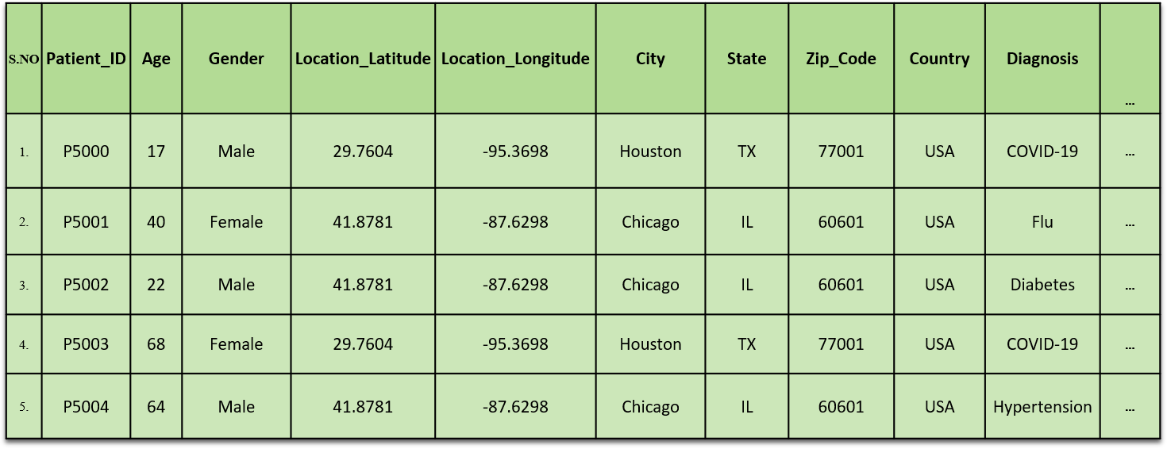

5. KEY VISUALIZATION:

ER Wait Times by Day and Time
Why it’s key:
This chart reveals patterns in emergency room wait times across different days and times, helping hospital staff anticipate peak hours and allocate resources more effectively.

ICU Utilization by Department
Why it’s key:
Displays how different departments utilize ICU beds, enabling administrators to identify capacity issues, redistribute resources, and enhance critical care planning.

Bed Occupancy Rates by Ward and Shift
Why it’s key:
Provides visibility into occupancy levels across hospital wards during different shifts. This helps improve patient flow, reduce congestion, and optimize admission/discharge processes.

Patient Recovery Rates by Treatment Type
Why it’s key:
Tracks recovery outcomes linked to various treatments or procedures. This insight supports data-driven decisions on best practices, care quality, and protocol standardization.

Admissions by Referral Source (Walk-in, Transfer, Online Booking)
Why it’s key:
Shows which referral sources are most effective in driving hospital admissions. This is critical for refining outreach strategies and understanding how patients are accessing care.

6. SECURITY FEATURES IMPLEMENTED:

Security was a fundamental aspect of the Wellness Metrics Unveiled dashboard, achieved through:

Access Control:
A login feature to access protected or personalized areas of the website by entering their credentials, typically a username/email and password.

User Authentication and Authorization:
✓ Access to IBM Cognos is secured through authenticated user credentials, ensuring that only authorized hospital personnel can view or manage the data.

Data Privacy:
✓ Sensitive patient and operational data are safeguarded using Cognos’ built-in data masking and permission-based visualization layers, ensuring compliance with healthcare data privacy standards.

INSIGHTS DERIVED:
The dashboard revealed several actionable insights to enhance hospital performance:
- Resource Allocation: Higher ICU and ER utilization rates highlight the need for improved allocation and scheduling of critical care resources.
- Patient Recovery Trends: Recovery rates varied across departments, indicating opportunities to standardize care protocols.
- Throughput Analysis: Bed occupancy and ER wait times exposed inefficiencies that can be resolved with better triage and discharge planning.
- Departmental Performance: Visualizations identified high-performing departments and underutilized facilities, aiding administrative decision-making.

SCREENSHOT OF DASHBOARD:

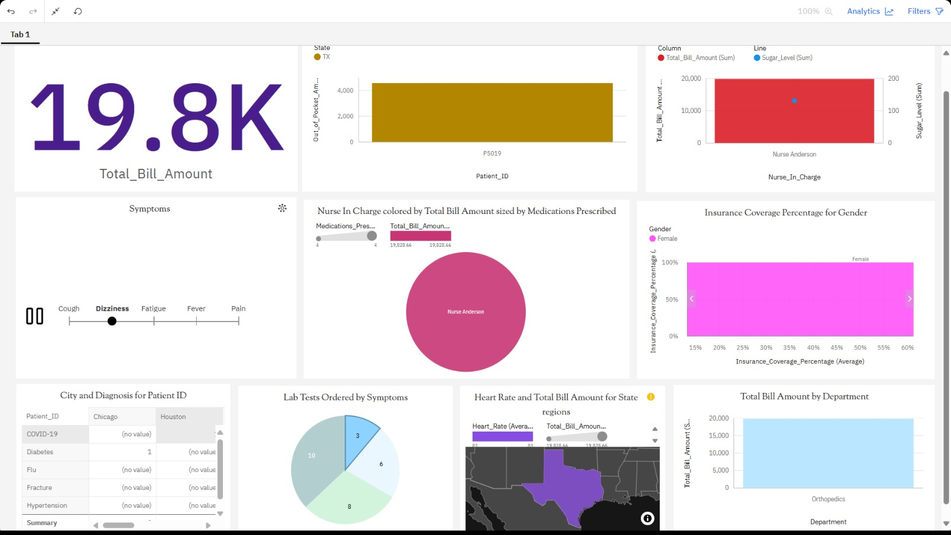

CONCLUSION:

Wellness Metrics Unveiled delivers a secure, insightful, and interactive business intelligence solution for hospitals. By tracking key healthcare KPIs such as bed occupancy, ER wait times, ICU utilization, and patient recovery rates, the dashboard empowers:

Improved operational decision-making

Enhanced patient care and resource management

Optimized critical care workflows

Increased efficiency through data insights

With integrated security features, the platform ensures that only authorized medical staff and administrators can access sensitive data—promoting compliance, patient privacy, and trust across the healthcare system.

